Exp.No-16
16.Perform Edge Detection using Canny Method

Aim:
To detect the edges of an image using the Canny Edge Detection algorithm in OpenCV.
Procedure:
- Start the program.
- Import the OpenCV library.
- Read the input image (puppy.jpg).
- Check whether the image is loaded.
- Convert the image into grayscale.
- Apply the Canny edge detection algorithm.
- Display the original image and the edge-detected image.
- Save the output image.
- Stop the program.
Program:
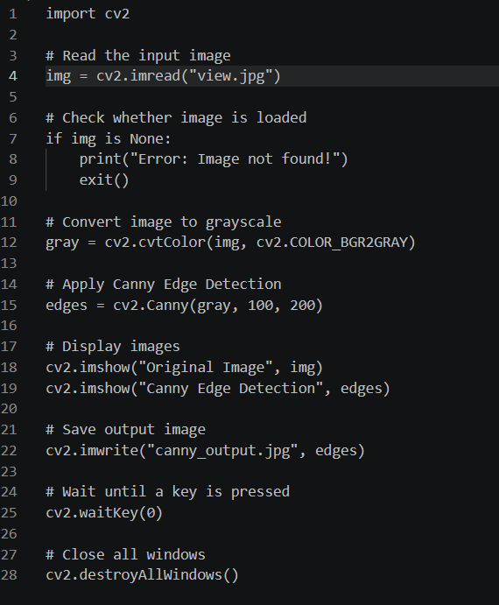
Input:


Output:
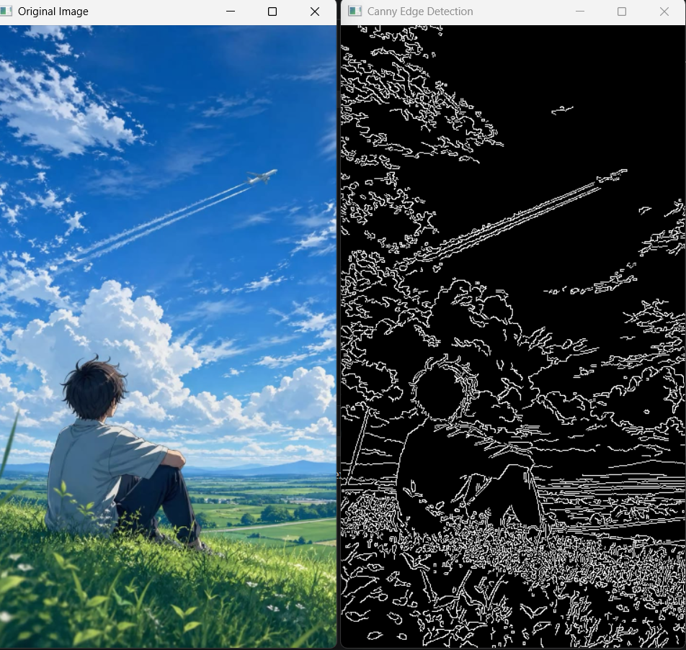

Result:
The edges of the input image were successfully detected using the Canny Edge Detection algorithm. The edge-detected image was displayed and saved successfully.

